1. What is LINQ Contains Method in C#?

The LINQ Contains Method in C# is used to check whether a sequence or collection (i.e. data source) contains a specified element or not. If the data source contains the specified element, then it returns true else returns false. There are there Contains Methods available in C# and they are implemented in two different namespaces. They are as follows.

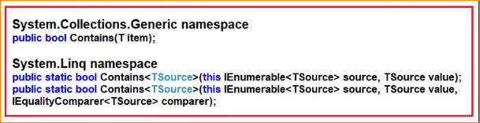

The Contains Method belongs to System.Collections.Generic namespace takes one element as an input parameter and if that element is present in the data source then it returns true else false.

There are two overloaded versions available for the Contains method that belongs to System.Linq namespace and one of the overloaded versions take IEqualityComparer as a parameter.

Note: The Contains method works in a different manner when working with complex type objects. For complex-type objects, it only checks the reference, not the values. In order to work with values, we need to use IEqualityComparer.

1. Example to Understand LINQ Contains Method in C# using Primitive Type Collection

Let us see an example to Understand LINQ Contains Method in C# using both Method and Query Syntax. In the following example, we are checking whether element 33 is present in the collection or not. The following example returns true as the data source (i.e. IntArray) contains the element 33. There is no operator called contains in Query Syntax, so we need to use Mixed Syntax.

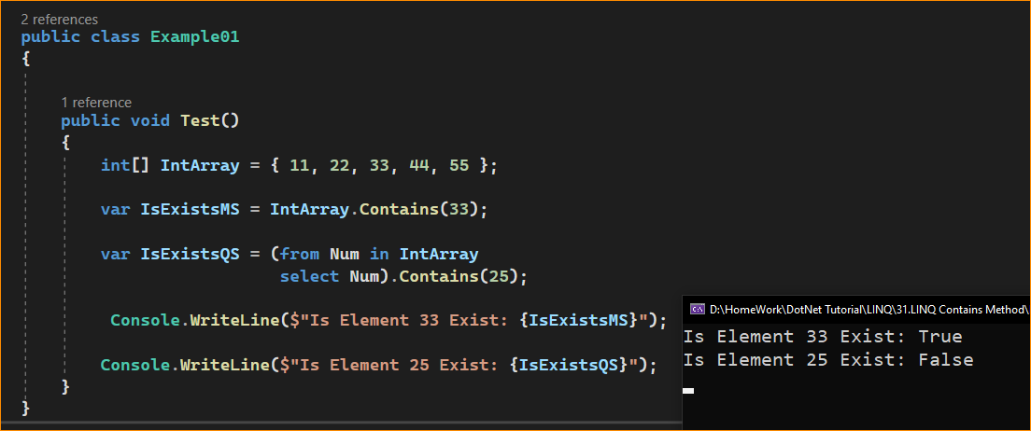

1. Example to Understand LINQ Contains Method in C# using String Type Collection.

Let us see an example of using the LINQ Contains Method in C# using String type collection. For a better understanding, please look at the following example, which shows how to use the Contains Method in C# with String type collection. In the below example, we are checking whether the string collection contains the name Anurag or not. The following example will return False as the sequence or data source contains no element named Anurag.

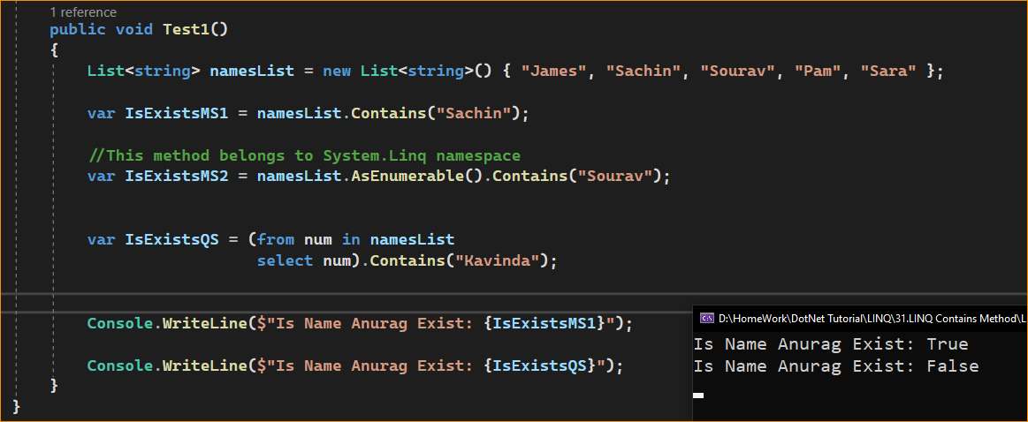

1. Example to Understand LINQ Contains Method with Complex Type in C#:

Let us see an example of using the LINQ Contains Method with Complex Data Type in C# using both Method and Query Syntax. We are going to work with the following Student. So, create a class file named Student.cs and copy and paste the following code. As you can see, the Student class has three properties such as ID, Name, and TotalMarks.

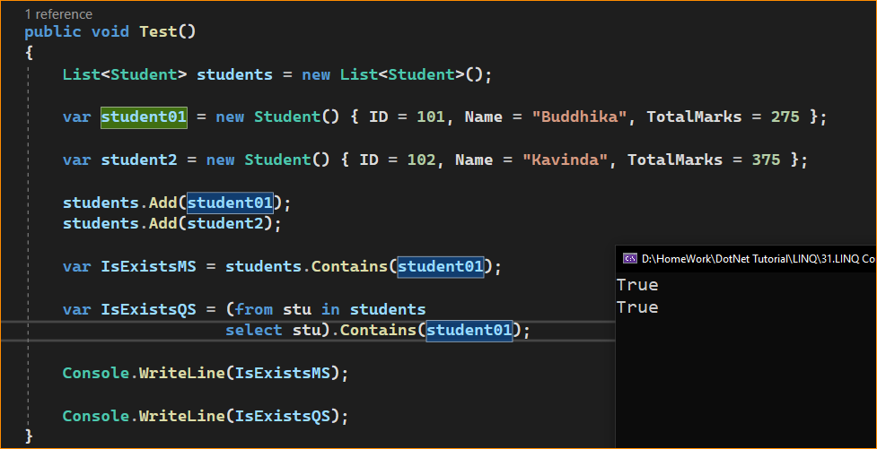

Now, let us create a new student object with the existing student object property value and pass that newly created student object to the LINQ Contains method. For a better understanding, please have a look at the following example. The following example will return False even though the values we passed are available in the data source. This is because the default compare, used by the LINQ Contains Method, does not check the values; rather, it checks the object reference, and in this case, the object references are different.

